369ai
H R S U I T E F O R O D O O 1 9
HR FIELD ATTENDANCE
HR Step-by-Step Guide

Attendance built from vehicle trips and customer visits — with GPS, fuel and trip totals.
A simple guide to running a day in the field: check in, log your trips and visits, and check out.
Module Version 19.0.1.15.4 · Odoo 19 · Human Resources
About This Module
HR Field Attendance is for people who work on the road rather than at a fixed desk — drivers, sales and service staff who move between the office and customer sites. Instead of a single check-in, a whole day's journey is captured on one attendance record: the trips taken, the customers visited, the distance and fuel used, and the GPS location for each leg.
This guide walks through a field day in the order you live it: check in, set up your first trip, add more trips and visits as the day goes on, head back home, and check out. Everything is driven by clearly labelled buttons on the attendance form, so you never have to guess the next step.
What the Module Gives You at a Glance
- A Field source flag — field attendance is marked separately from manual office attendance.
- One primary trip plus unlimited additional trips — a full day of stops on a single record.
- Customer visits — each visit is linked to the trip it happened on.
- GPS capture — latitude and longitude from the trip or the first visit.
- Trip Totals — total distance, duration, fuel litres and fuel amount across every trip.
- Guided buttons & pop-ups — set up the primary trip, add trips, and close the previous trip automatically.

Who this is for: Field Employees who record their day, and HR Officers / Managers who review field attendance, GPS, visited stops and the trip totals afterwards.

PART 1 FINDING YOUR FIELD ATTENDANCE

Field attendance lives in two convenient places, so you can reach it from the main menu or its app-launcher icon.
1 | Open the Field Attendance list

From the main menu open Attendances → Field Attendance. You land on My Field Attendance, which shows only your own records. There is also a Field Attendance app icon in the app launcher (the nine-dot grid) that opens the same screen.
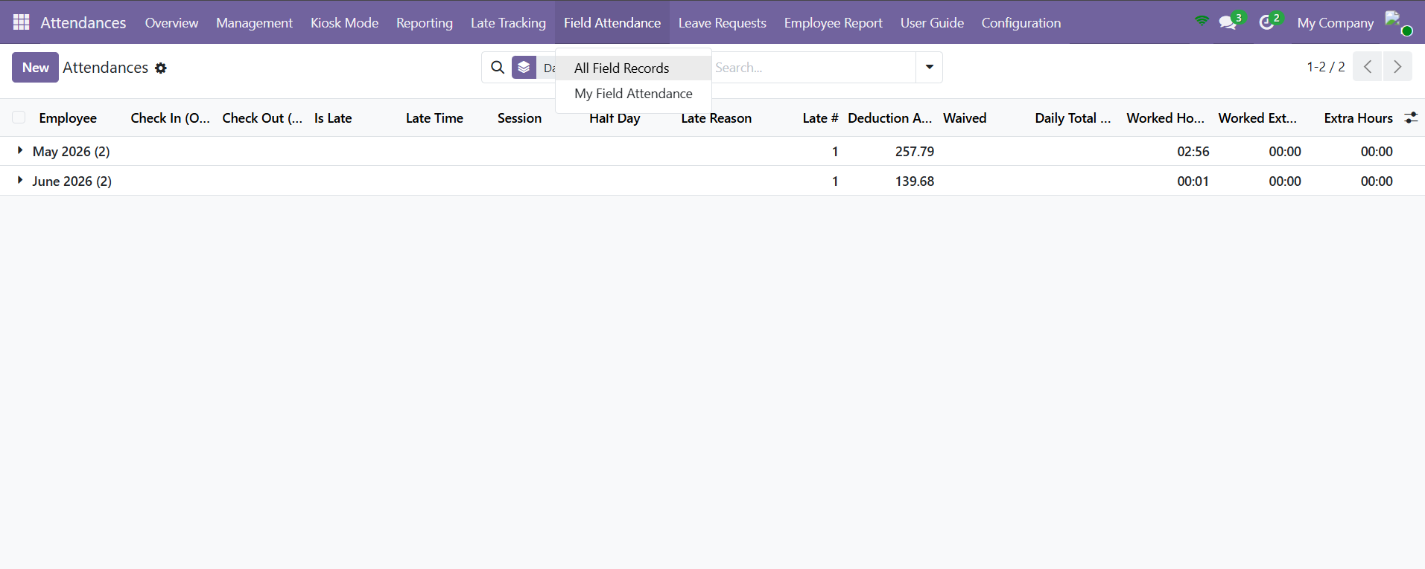
The Field Attendance menu — My Field Attendance and All Field Records.
- My Field Attendance — every employee sees their own field days here.
- All Field Records — HR Officers and Managers see everyone's field attendance.

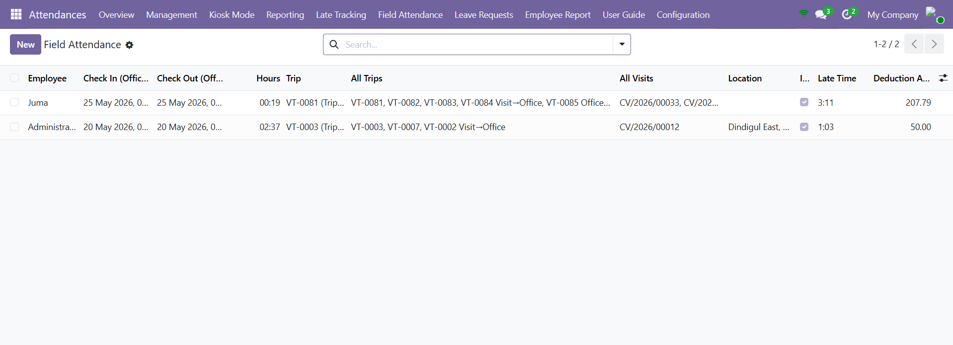
The Field Attendance list view.
TIP The list shows the date, employee, check-in and check-out (in office time), the source trip, the visited stops, the location and the trip totals — a quick way to scan a day before opening it. Use the Late Only, With Deduction and Waived filters to narrow it down.

PART 2 THE FIELD ATTENDANCE FORM

Opening a field attendance record shows the standard check-in / check-out header plus a Field Attendance area built from three parts.
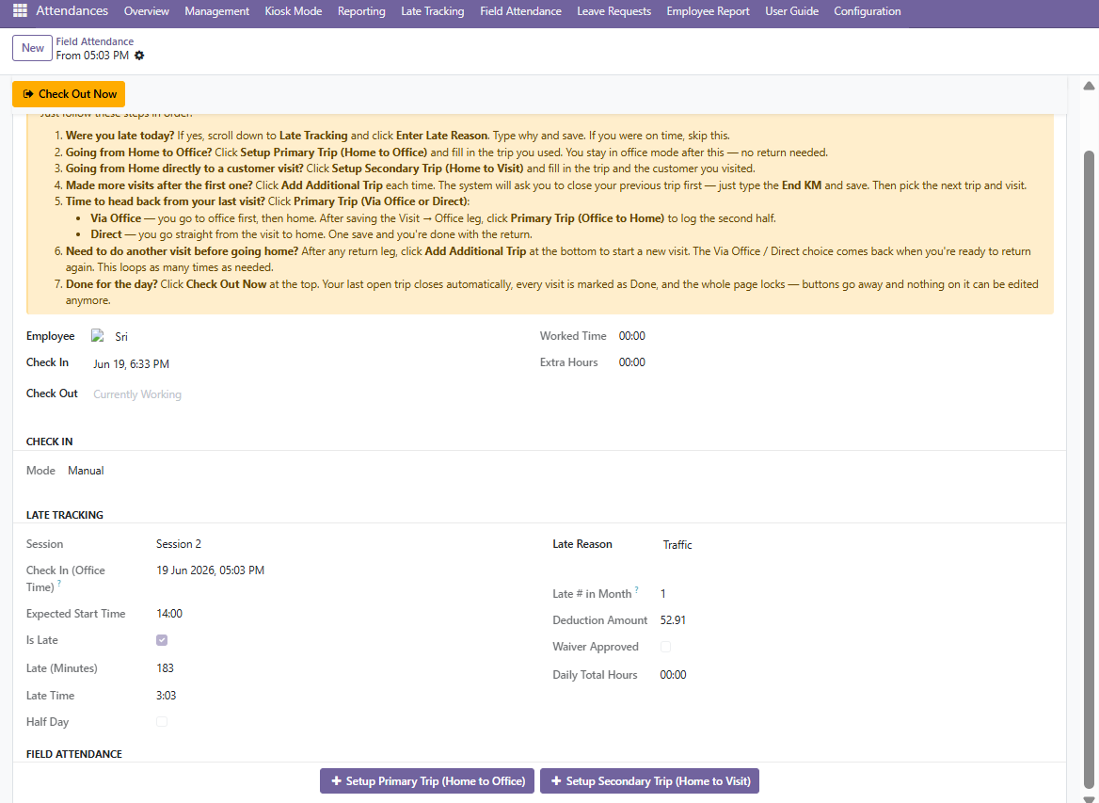
The field attendance form — guidance banner, Late Tracking and the trip buttons.
2 | Read the Primary Trip Card

The primary trip card is the main trip of the day — usually Home → Office. It shows the Source Trip, the Source and Destination Location, KM Travelled and Duration, the GPS Latitude and Longitude, and a Location name. From the card you can Edit Primary Trip, Open Source Trip, View Visits or Add Fuel.
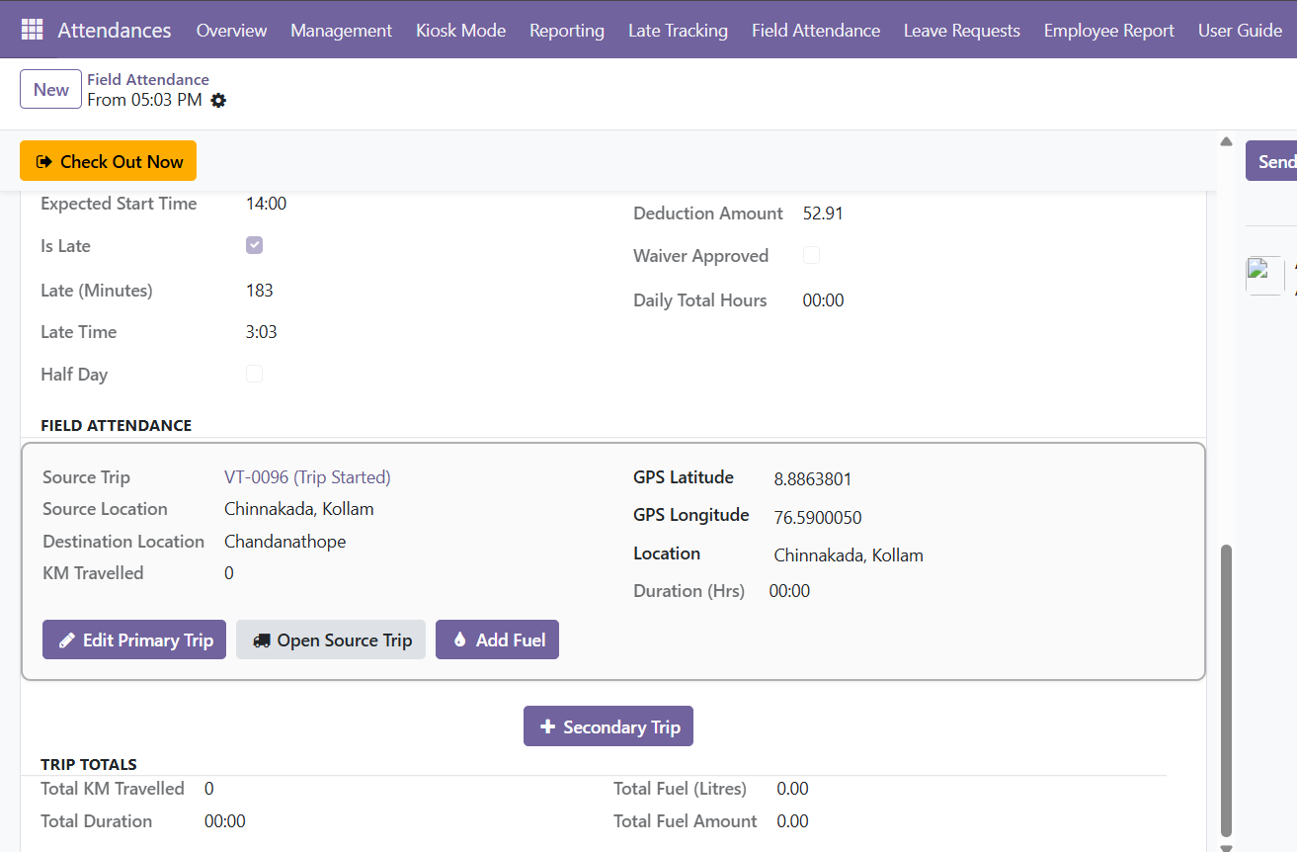
The Primary Trip card, with Trip Totals below.
3 | Read the Additional Trips & Return Home sections

Each extra trip appears as a card with two columns: Trip Details (source, destination, KM, duration, GPS) on the left and Visit Details (the customer, date, location and GPS of the visit) on the right. When you start heading back, the return legs are grouped under a Return Home section and labelled Visit → Office, Office → Home or Visit → Home (Direct).
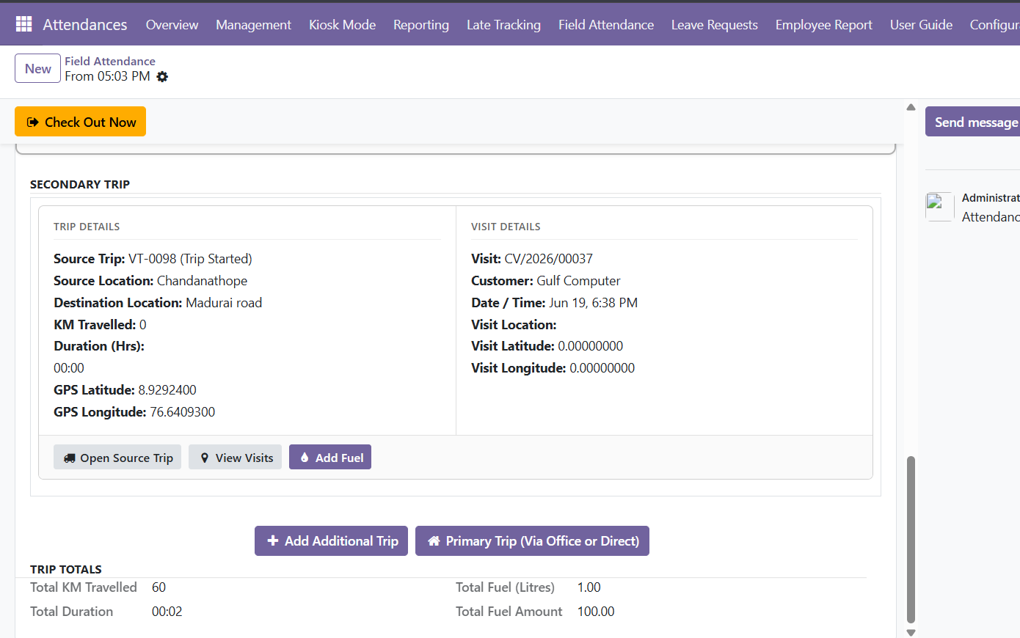
An additional trip card — Trip Details on the left, Visit Details on the right.
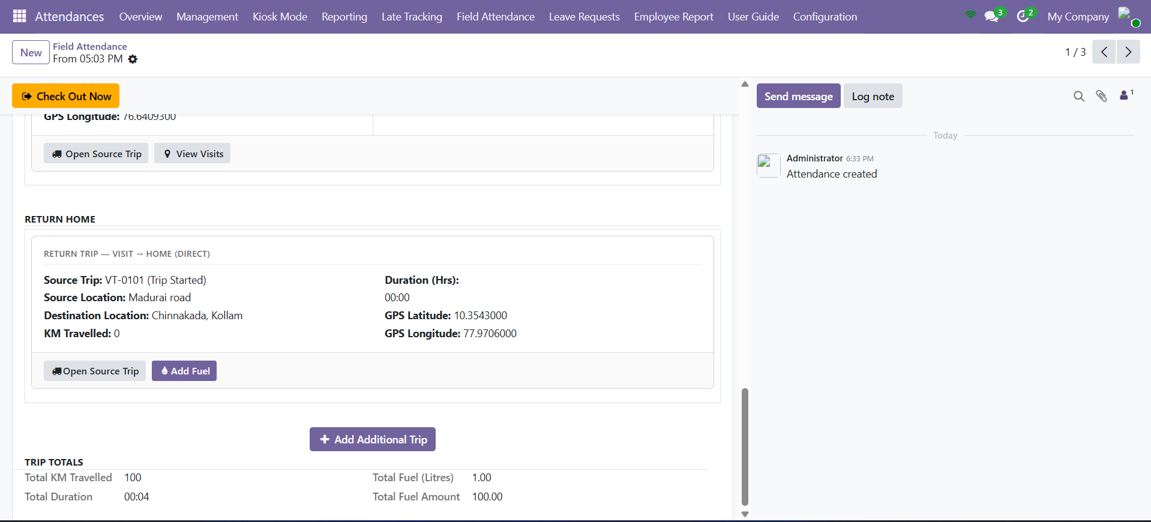
The Return Home section — a Visit → Home (Direct) leg.
4 | Read the Trip Totals

The Trip Totals group adds everything up for the day: Total KM Travelled, Total Duration, Total Fuel (Litres) and Total Fuel Amount. These are calculated automatically from all the trips on the record. Every time on the record — each trip's Start Time and End Time, and each visit's Date / Time — is now shown in the company's Office Timezone. Start Time and End Time are read-only: they are captured automatically when you start and close a trip, so you no longer type them in.

PART 3 A DAY IN THE FIELD

This is the heart of the module — the buttons you press, in order, across a working day.
5 | Check in

Start your day with a check-in. The attendance is marked as a Field source and the workflow guidance banner appears to point you to the next action.
6 | Enter a late reason (only if you were late)

If you arrived late, scroll to the Late Tracking section and click Enter Late Reason, then type why. If you were on time, skip this step.
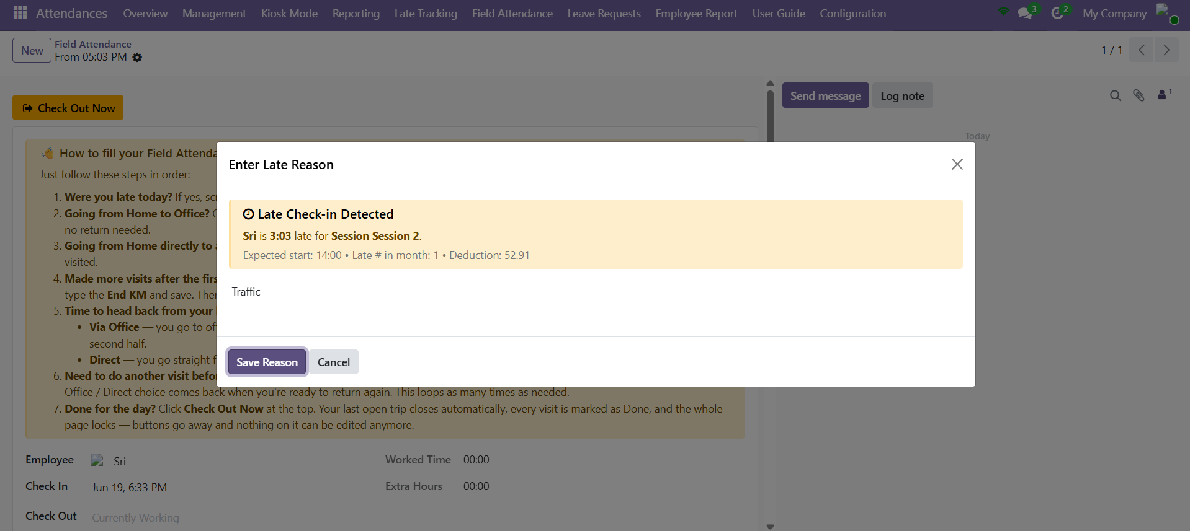
The Enter Late Reason pop-up.
7 | Set up your primary trip

Click Setup Primary Trip (Home to Office). Pick the trip from the Pick a Trip list, enter the Start KM, optionally name the Location, and click Save. The trip starts automatically and the primary card fills in. If you are going straight from home to a customer instead, click Setup Secondary Trip (Home to Visit) and choose the trip and the visit.
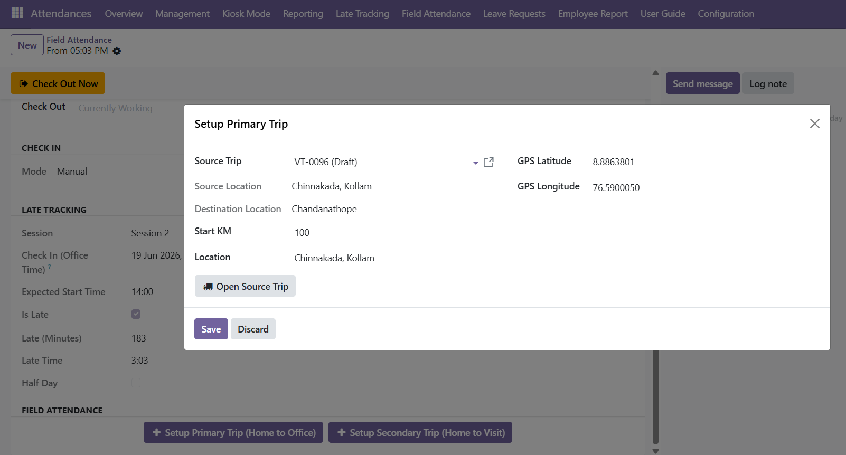
Setup Primary Trip — pick a trip, enter Start KM and save.
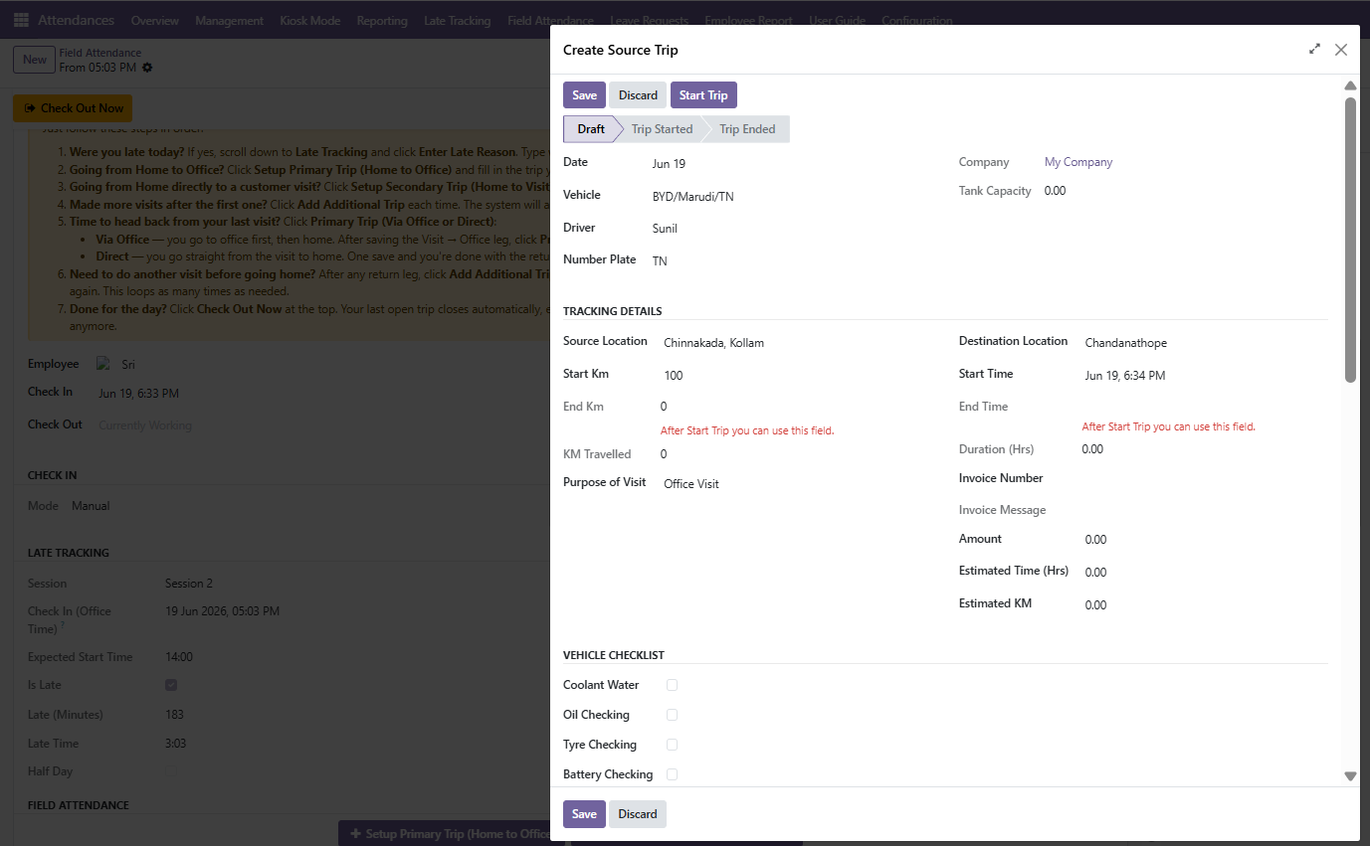
Creating the source trip — tracking details.
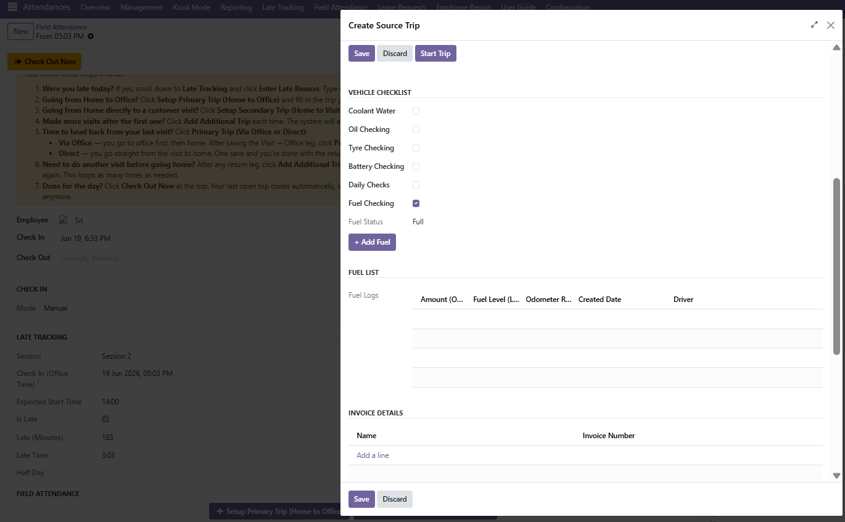
Vehicle checklist, fuel and invoice details on the trip.
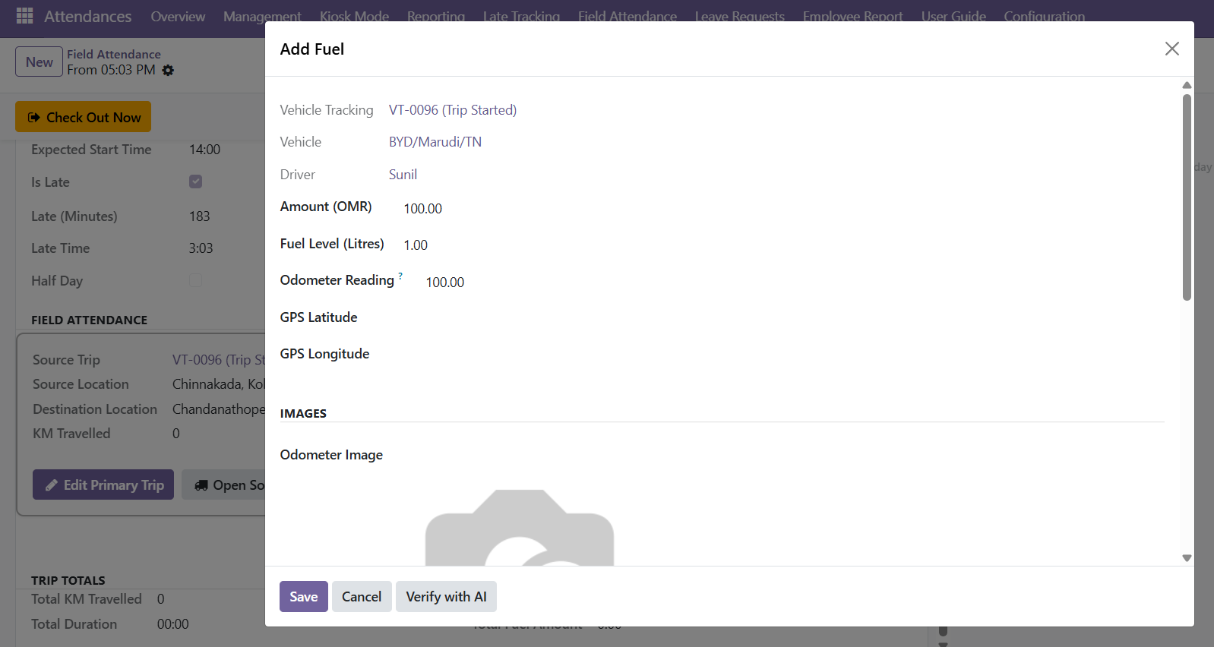
The Add Fuel pop-up.
8 | Add additional trips as you move

Each time you drive to a new stop, click Add Additional Trip. If a trip is still open, a Close Previous Trip pop-up appears first — enter the End KM and click Save & Exit; the open trip is ended automatically and the next trip's pop-up opens. Pick the trip and the visit, enter the Start KM, and save. The Start KM is pre-filled from the previous trip's End KM, so you usually just confirm it.
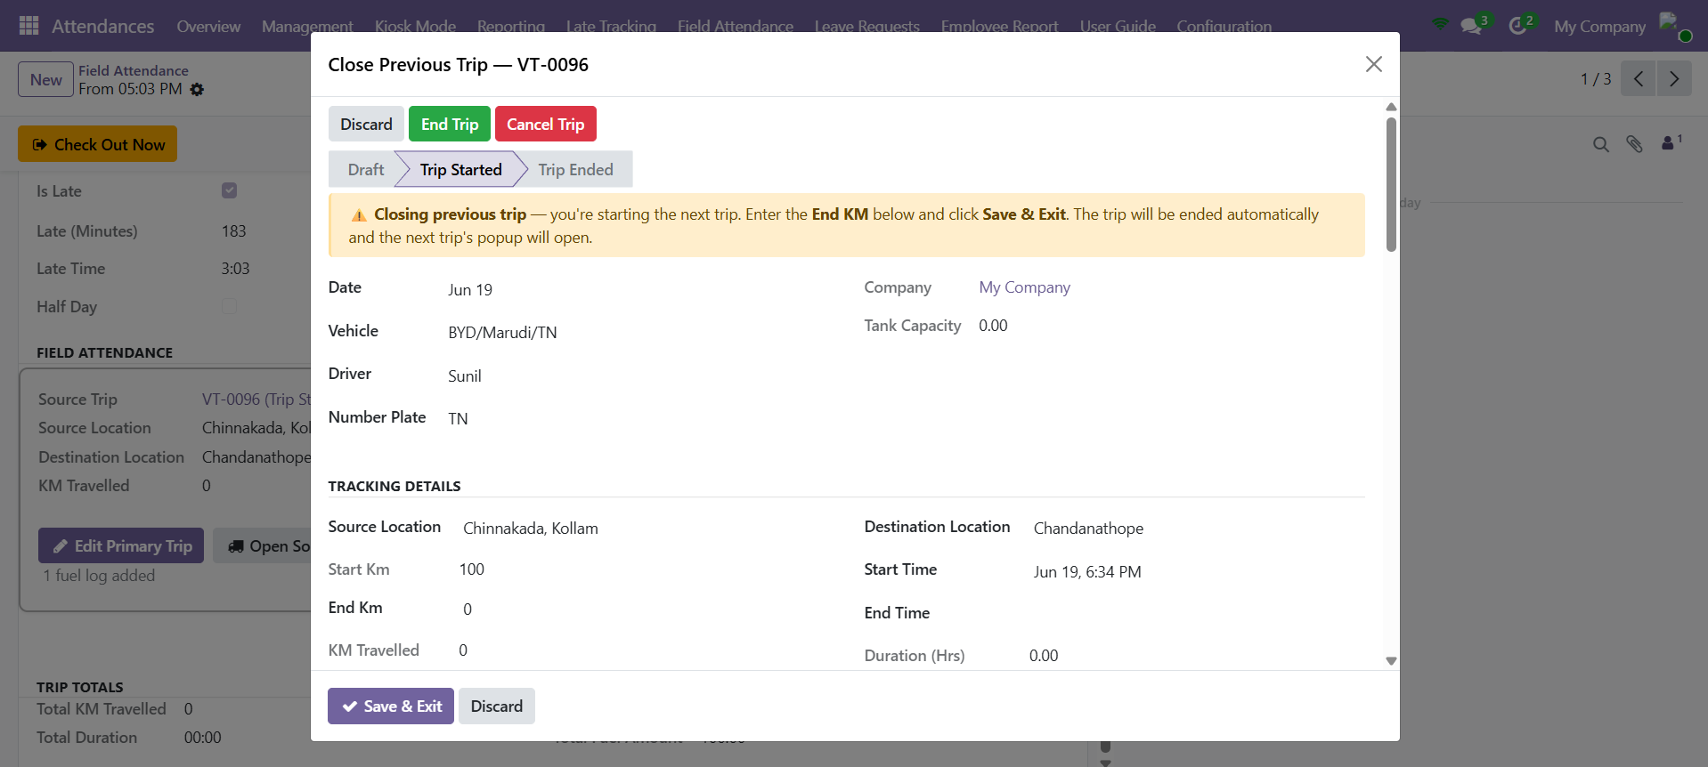
Close Previous Trip — enter the End KM, then Save & Exit.
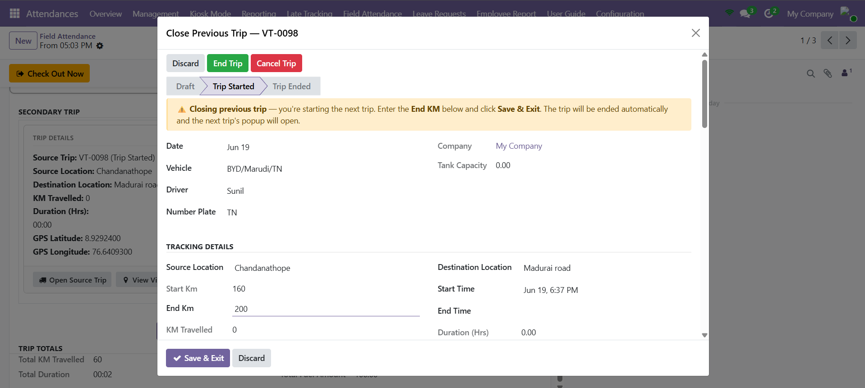
Closing the previous trip with the End KM entered.
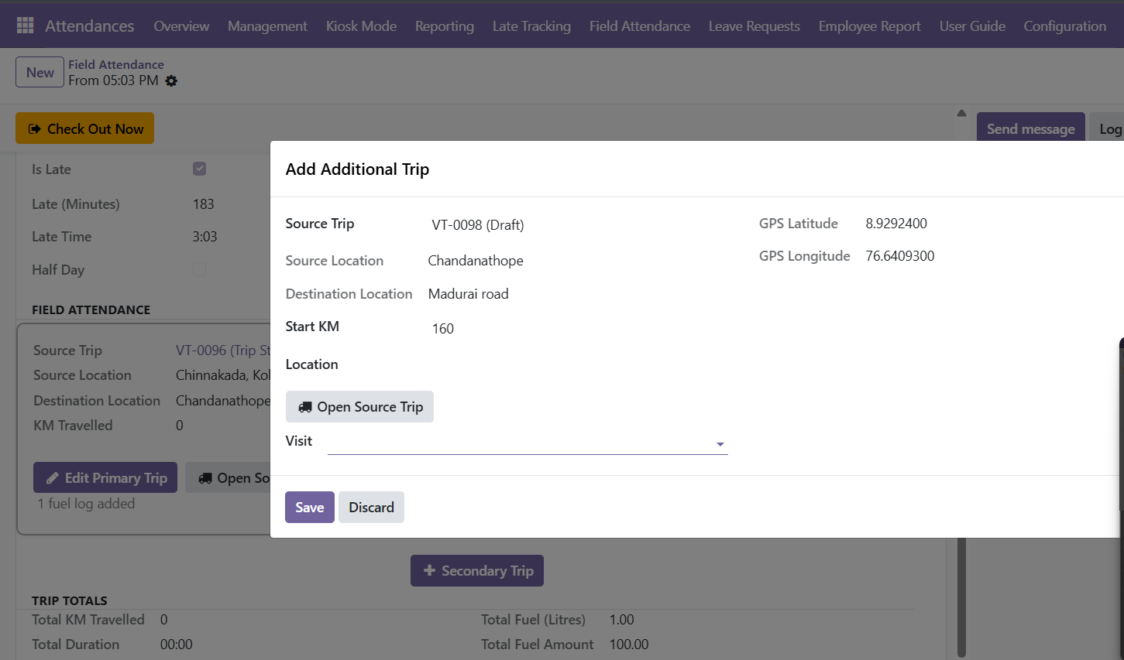
Add Additional Trip — choose the trip and the visit.
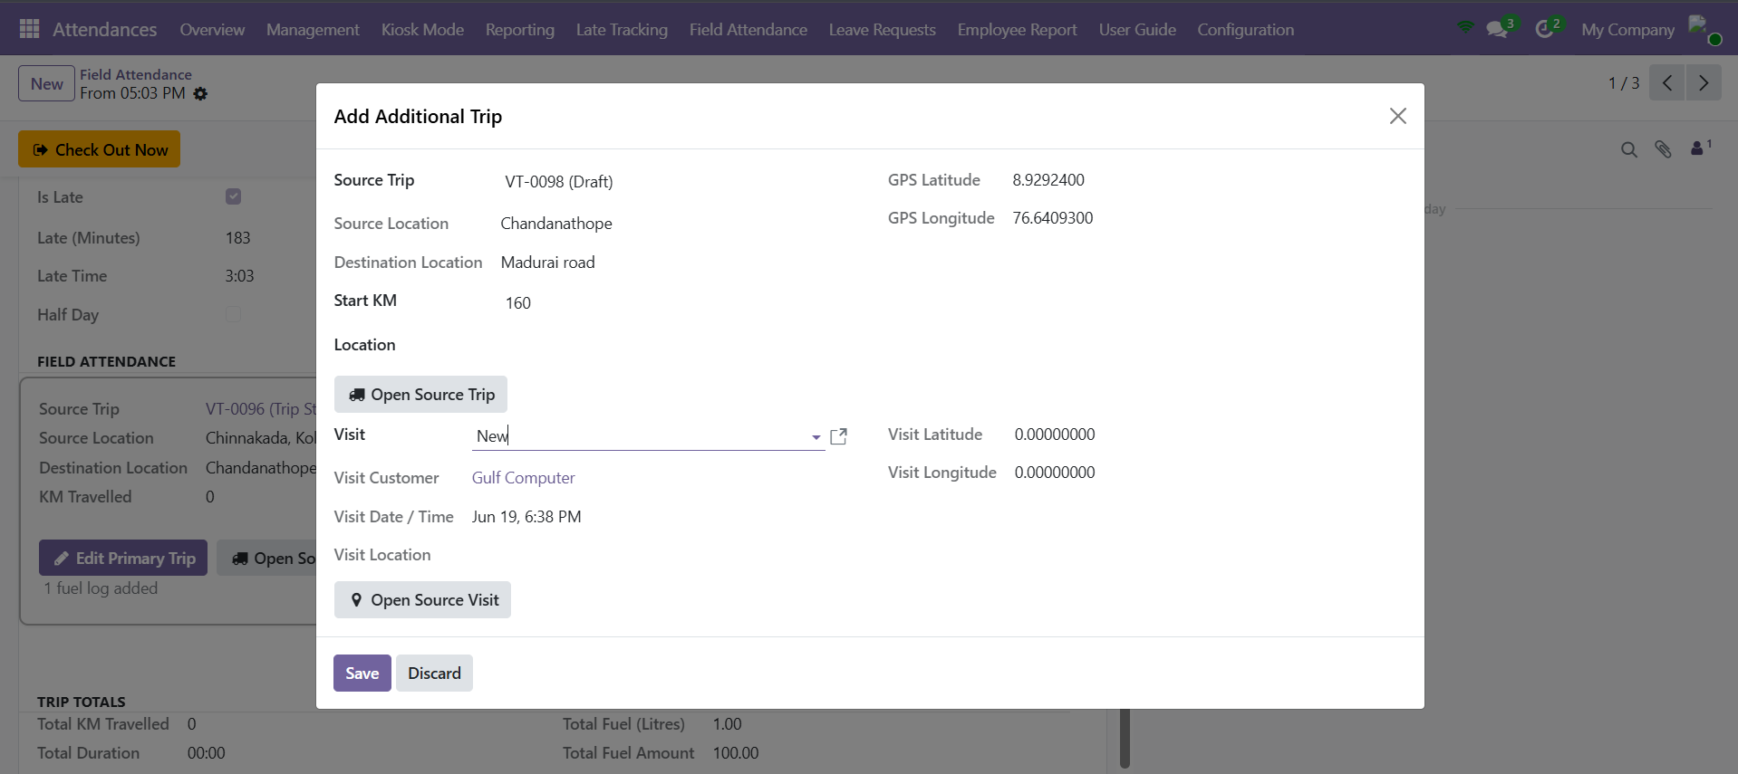
Add Additional Trip with its customer visit attached.
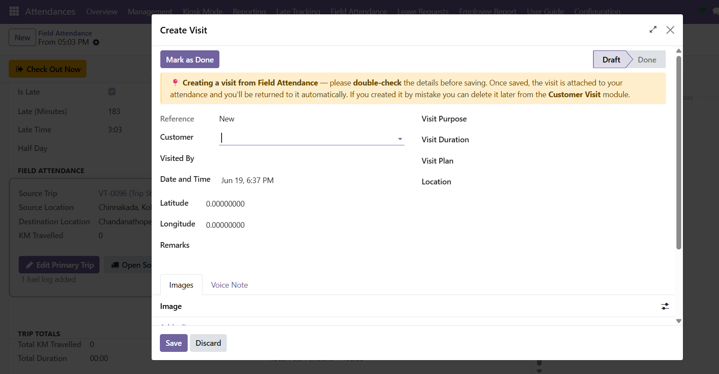
Creating a customer visit from the field-attendance flow.
NOTE Adding a new trip always closes the previous one first, so your distance and fuel figures stay accurate. Ended trips are locked and hidden from the trip picker.

9 | Head back home

When you are ready to return, click Primary Trip (Via Office or Direct) and choose a route: Via Office (Visit → Office, then Office → Home) or Direct (Visit → Home). For the Via Office route, after the first leg saves, the Primary Trip (Office to Home) button appears for the second leg.
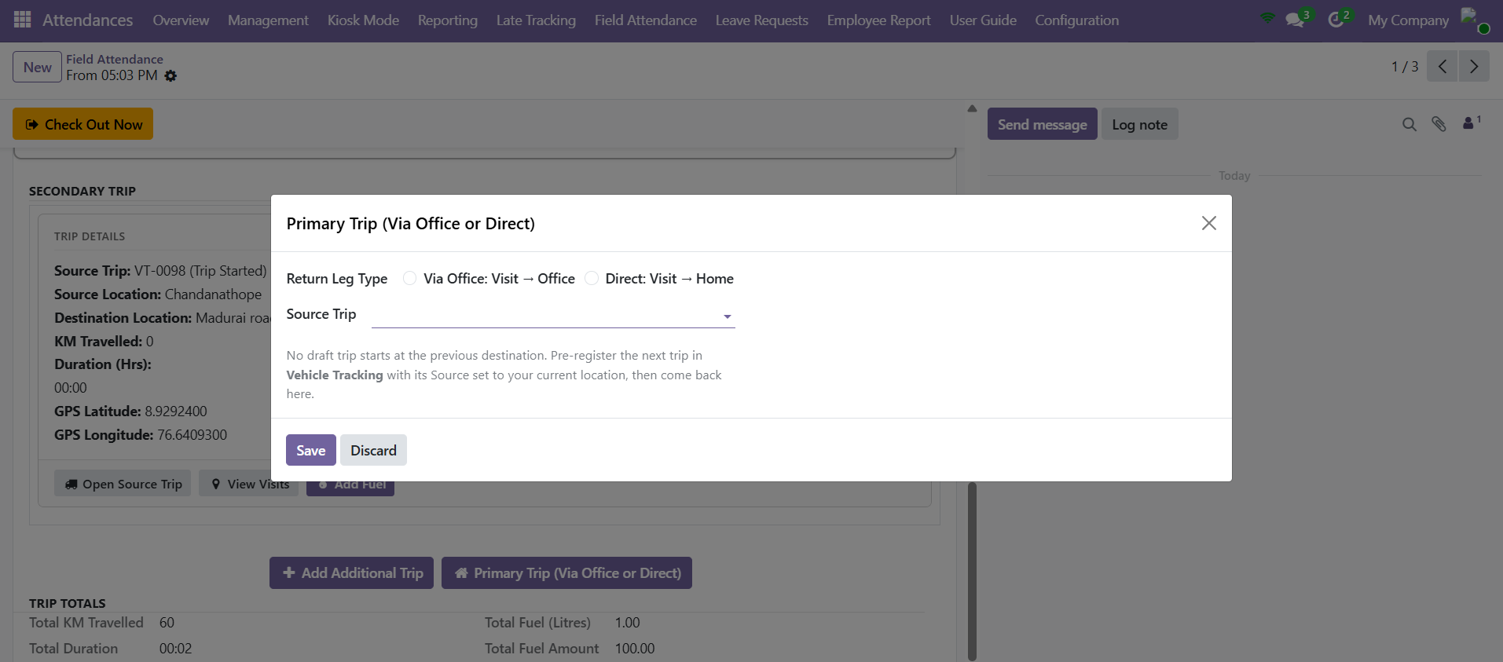
Primary Trip (Via Office or Direct) — choose the return route.
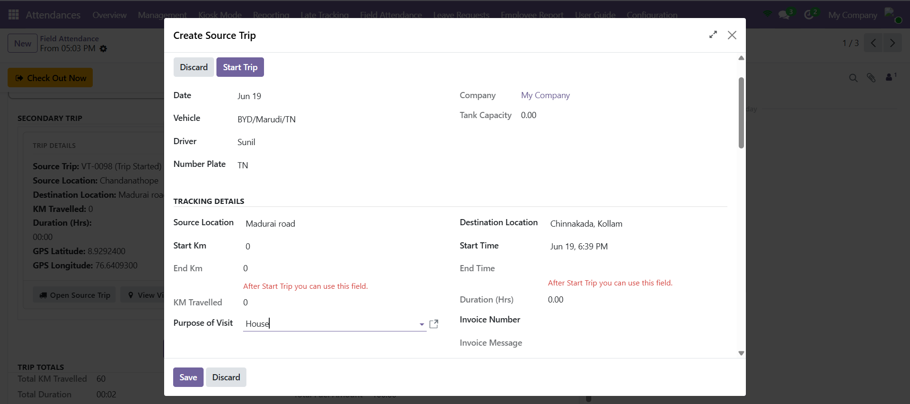
Creating the return source trip back home.
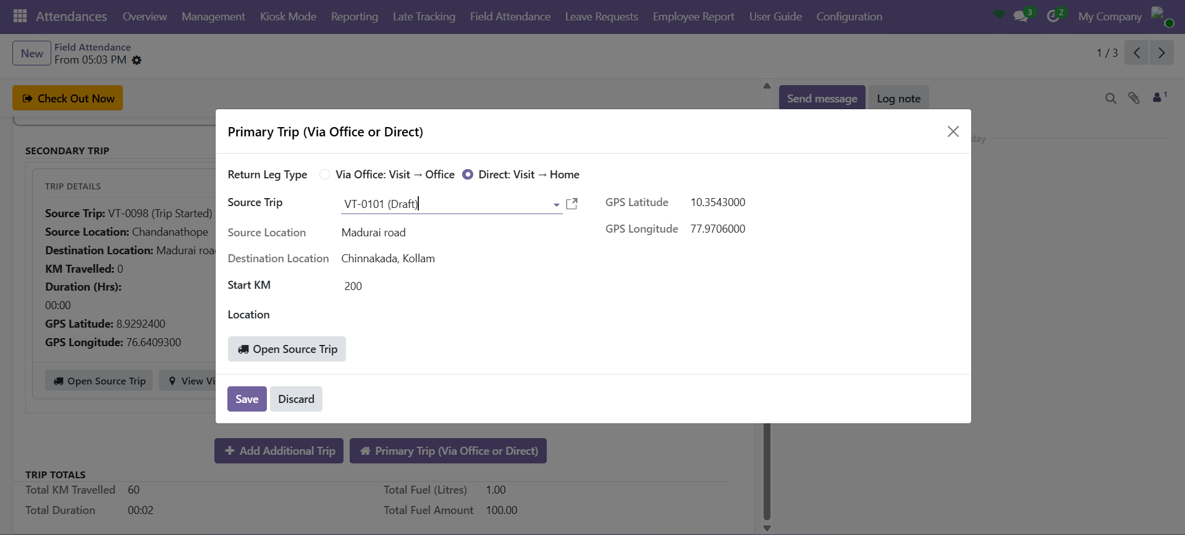
The Direct (Visit → Home) return leg selected.
10 | More visits before home (optional)

Need one more visit after starting back? Click Add Additional Trip again — the Return Home section steps aside and a fresh outbound trip begins. Repeat the cycle as many times as the day needs.
11 | Check out

At the end of the day click Check Out Now at the top. If a trip is still open you are asked for the End KM first (Save & Exit). On check-out the last trip is closed, every visit is marked Done, and the whole record locks read-only.
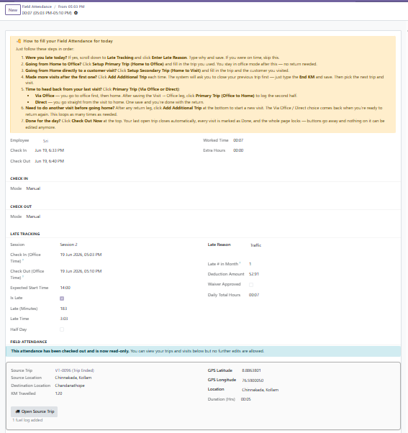
After check-out the record is locked read-only.
IMPORTANT Once an attendance is checked out it becomes read-only and the action buttons disappear. Double-check your trips and End KM before you check out.

PART 4 REVIEWING FIELD ATTENDANCE

12 | Review field attendance

Managers open All Field Records to review any employee's day. Group by Employee, Department, Trip, Date or Month, and filter by My Records, Late Only, With Deduction or Waived. Open any record to inspect the trips, visits, GPS and trip totals.
Trip Deviation Check
A trip can carry an estimate — Estimated KM and Estimated Time. When the trip is closed, the actual distance and duration are compared against that estimate (plus the tolerances HR sets in Late Tracking configuration). The result shows as a Trip Check status:
- Within Estimate — the trip stayed inside the allowed KM and time. Nothing more to do.
- Over — Check — the trip went beyond the estimate. A Deviation Reason becomes required before the record can be saved; type why the trip ran longer (detour, traffic, extra stop) in the box “Reason for going beyond the estimated KM / time…”.

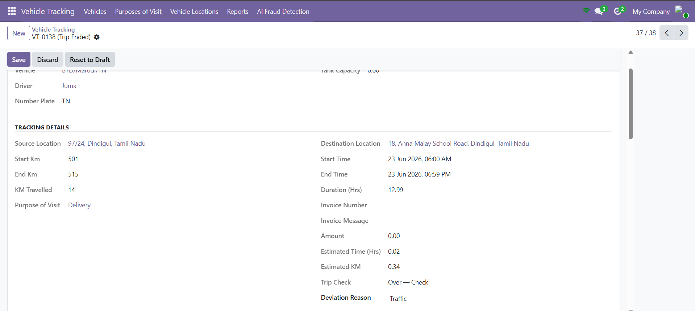
An ended trip flagged Over — Check — the Estimated KM / Time, the Trip Check status and the required Deviation Reason.
Reviewing deviations — Managers open All Field Records → Trip Summary (grouped by Employee and Date). Alongside the usual trip columns it shows:
- Extra KM — how far the trip went over its estimated distance.
- Extra Time (Hrs) — how long the trip ran over its estimated time.
- Trip Check — Within Estimate or Over — Check; rows that are over are highlighted in red.
- Deviation Reason — the explanation the employee entered.

Use the Over / Check filter to list only the trips that exceeded their estimate, and group by Employee or Date to scan them quickly.
Quick Reference — Buttons
Button | When to use it
Setup Primary Trip (Home to Office) | Start the day's main trip from home to the office.
Setup Secondary Trip (Home to Visit) | Go straight from home to a customer visit.
Add Additional Trip | Record the next stop; closes the open trip first.
Primary Trip (Via Office or Direct) | Begin the journey home — via office or direct.
Primary Trip (Office to Home) | Second leg of the via-office return.
Open Source Trip / View Visits | Open the full trip record or the linked visits.
Add Fuel | Log fuel against the current trip.
Check Out Now | End the day; closes the last trip and locks the record.

Things to Remember
- Check in first — the form guides you to each next button.
- Always enter the End KM when closing a trip so distance and fuel stay correct.
- Use Via Office or Direct to match how you actually travel home.
- Trip Totals add up KM, duration and fuel automatically across every trip.
- Checking out marks all visits Done and locks the record — review before you check out.
- All trip and visit times are shown in the Office Timezone; a trip's Start and End times are captured automatically when you start and close it.
- If a trip exceeds its estimated KM or time, a Deviation Reason is required — it appears in the Trip Summary for managers to review.

— End of Guide —
369ai.Biz | HR Field Attendance — HR Guide

